**Assignment 2: Install MongoDB Database**

**Step 1:**

Go To Cloud9 and create Environment.

Name: AWSDemoPurpose

Description: for aws demo

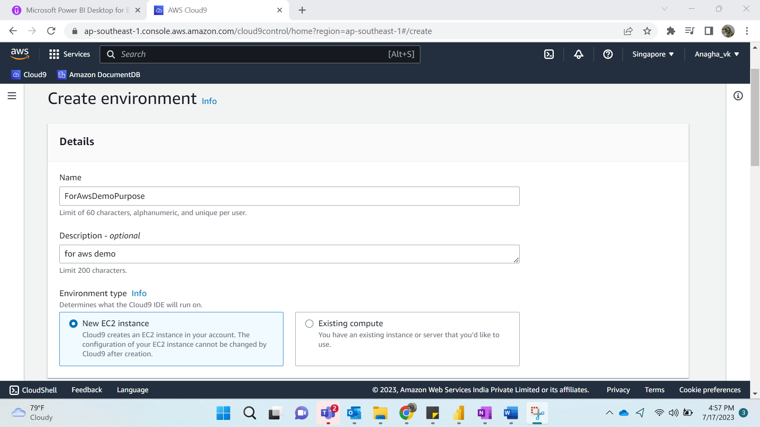

Keep the Default settings.

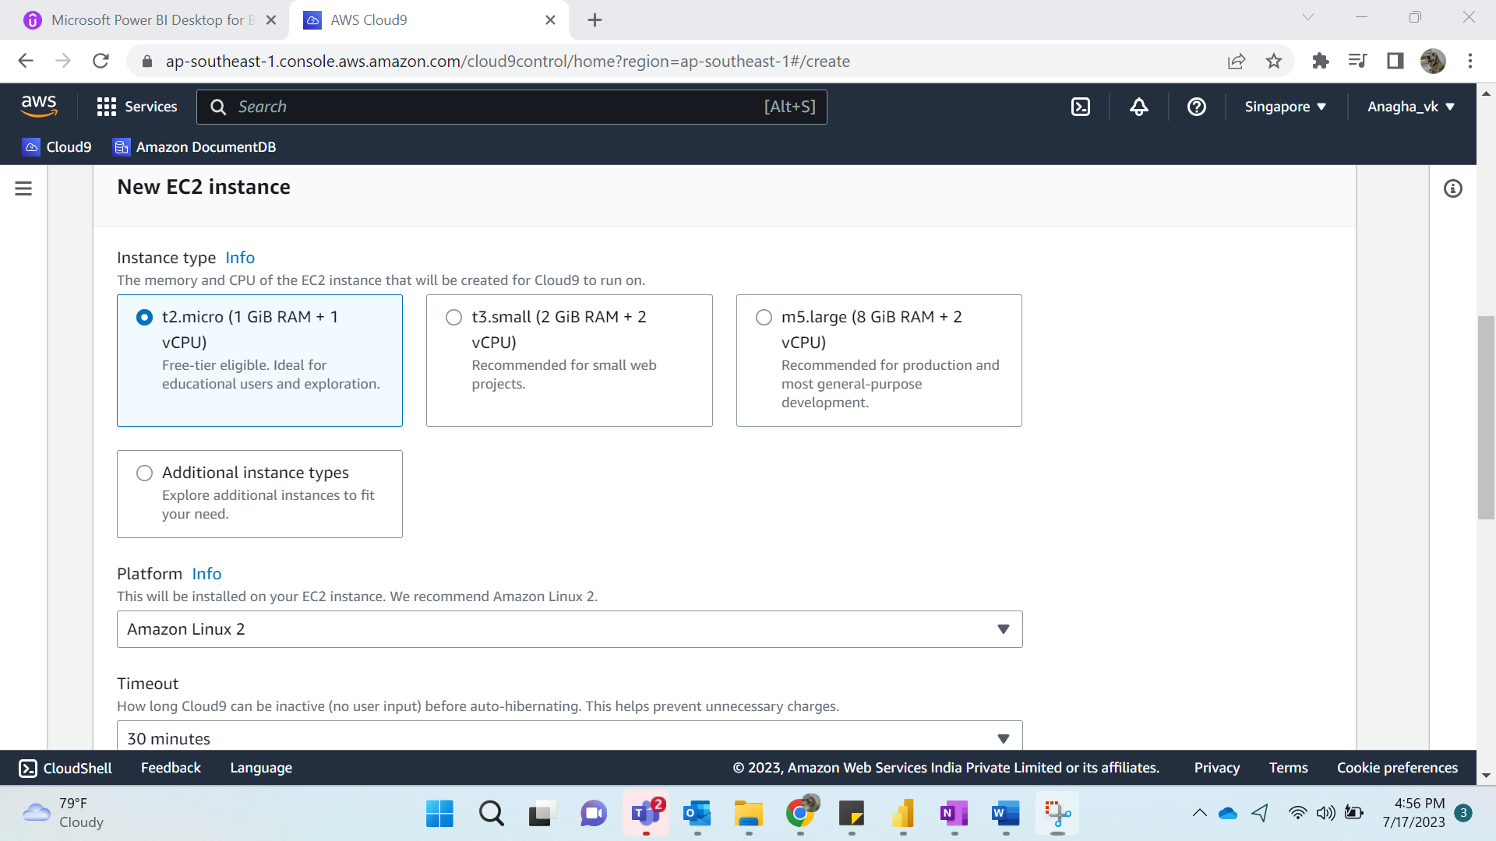

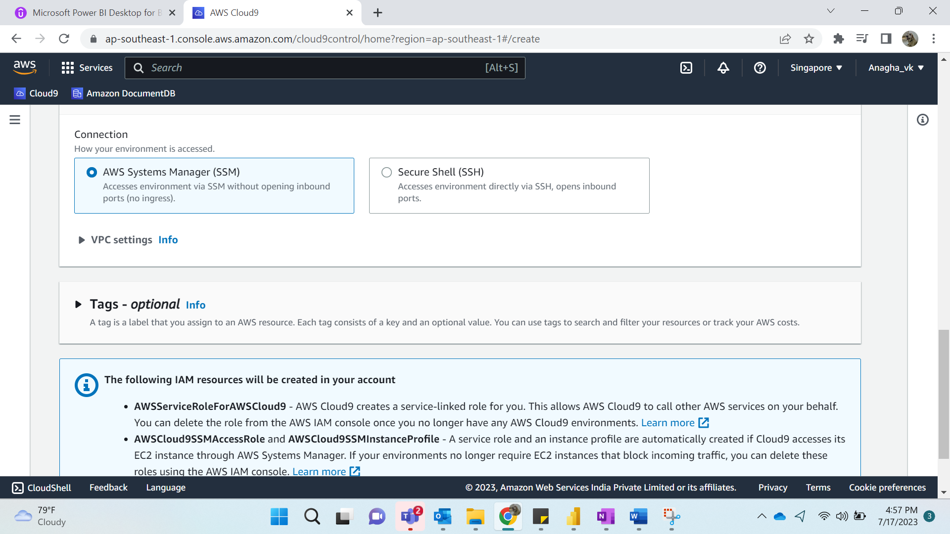

Click on -> Create

Result:

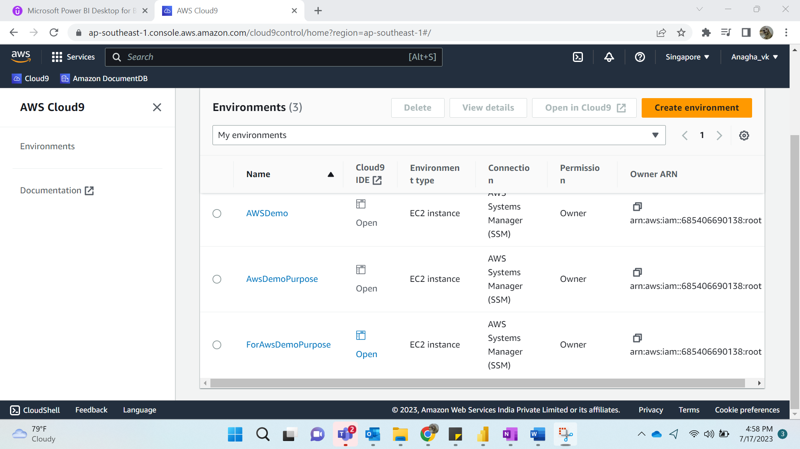

**Step 2:**

We create a security group.

Name: SG_Test

Inbound Rules: Port range: 27017, custom: SG group will be the one that was created by EC2 instance.

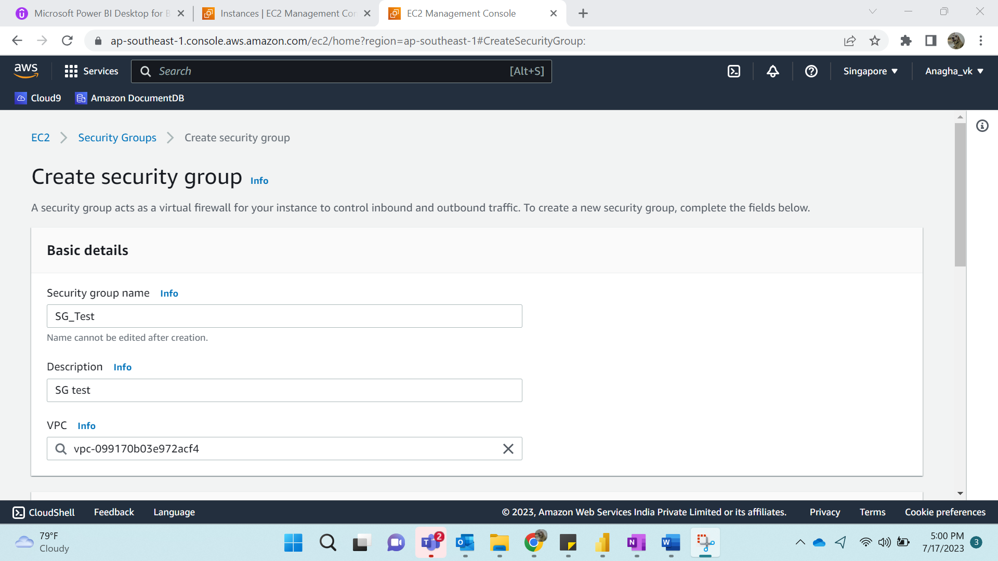

The Security Group by the ec2 instance:

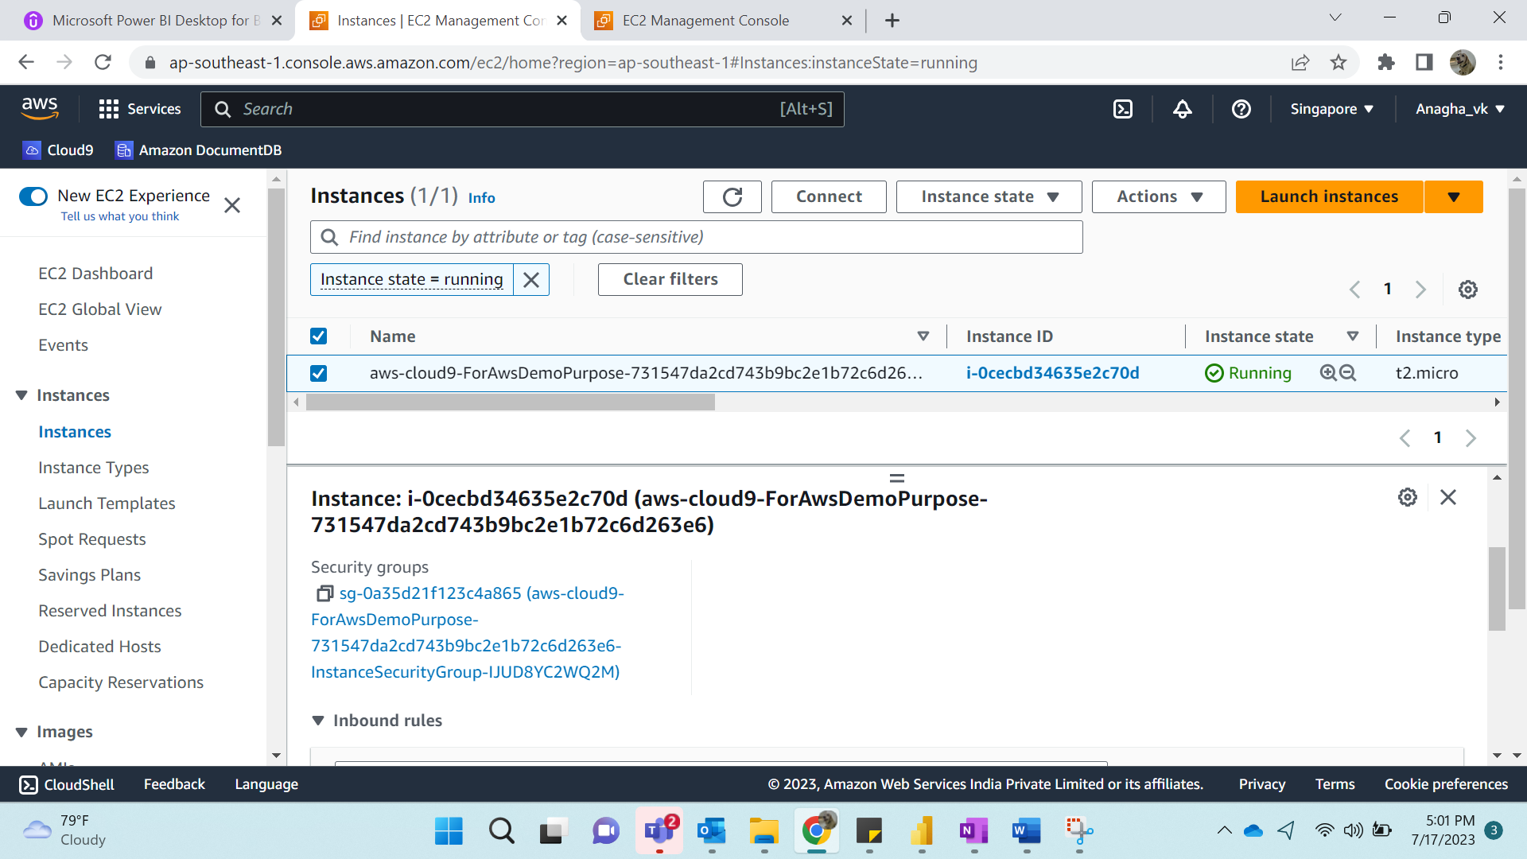

Inserted as follows:

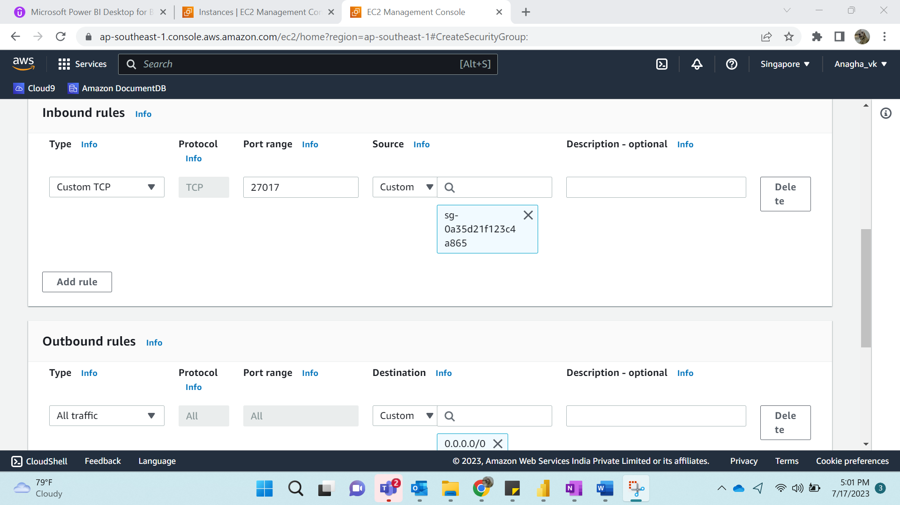

Click-> Create Security Group

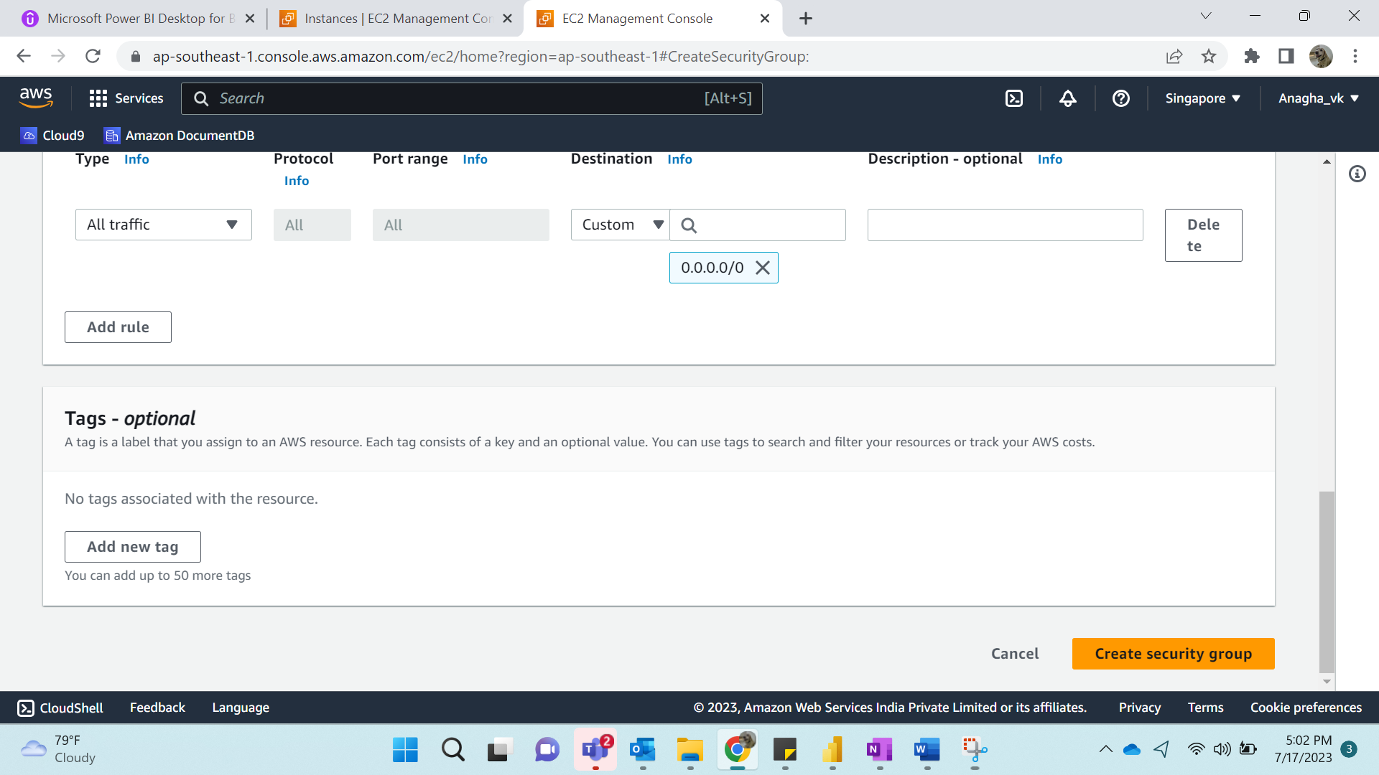

Result:

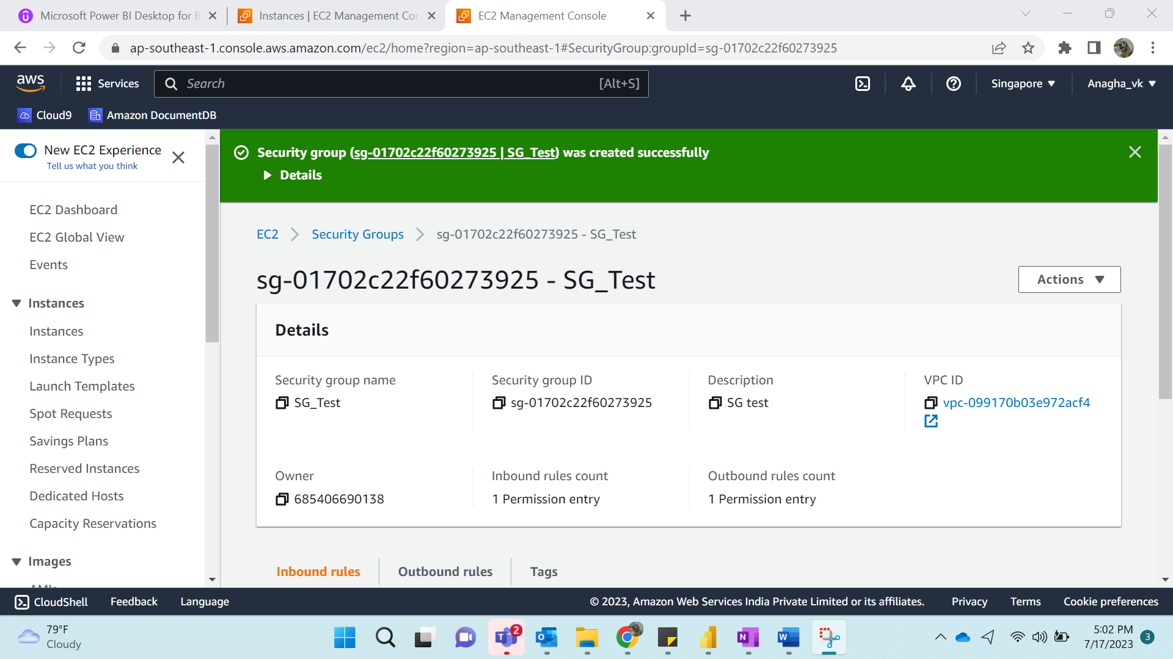

**Step 3:**

Go to amazon DocumentDB. Select Instance based Cluster, Name-> ForAssign1Demo, number of instances: 1, name: root, password: <customized>, GoTo Advanced Settings-> add the security group that we created. (SG_Test)

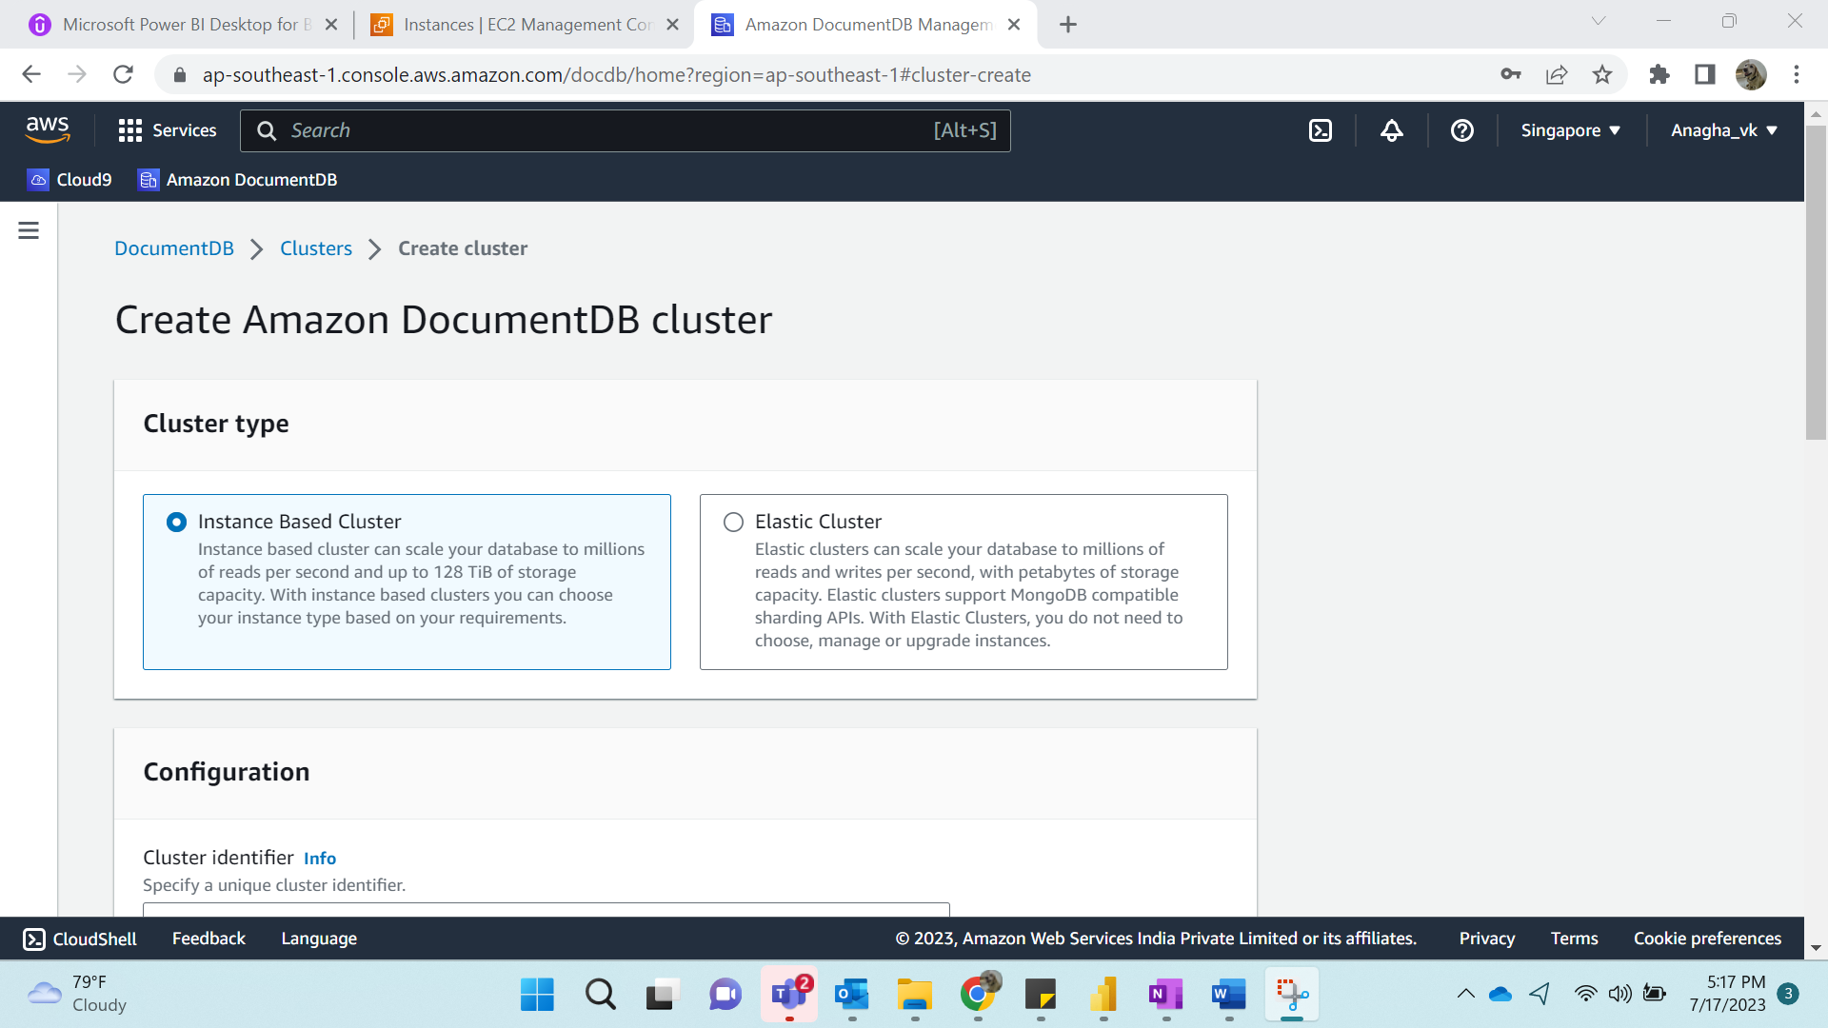

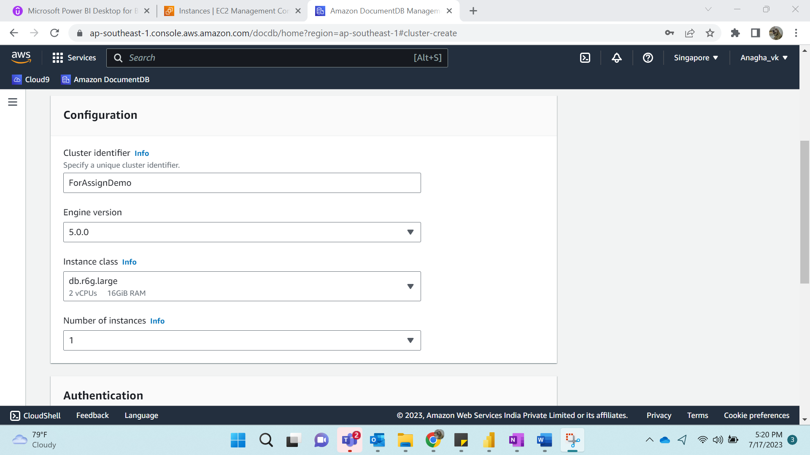

Adding UserName & Password:

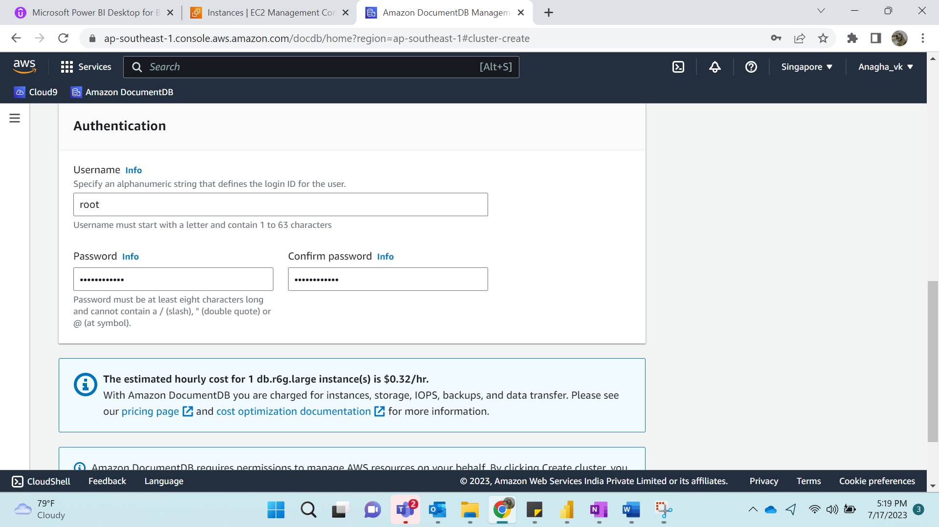

Result:

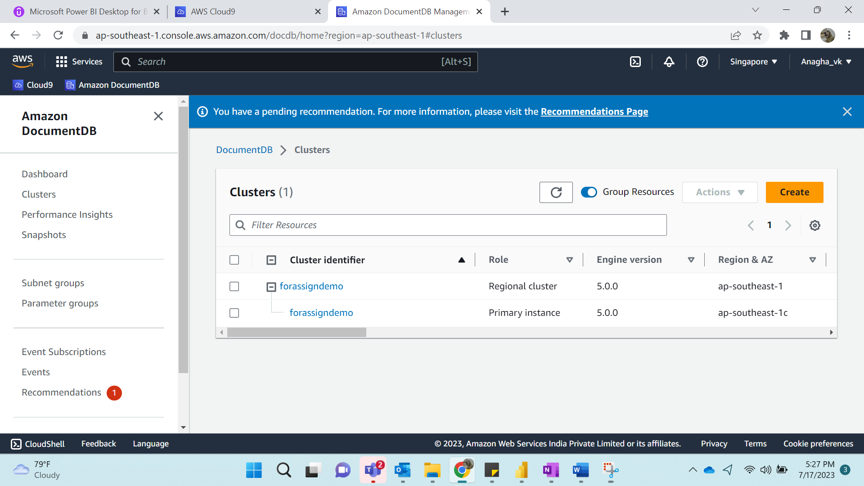

**Step 4:**

Go to Cloud9 and OPEN IDE->

Click on Open for AWSDemoPurpose

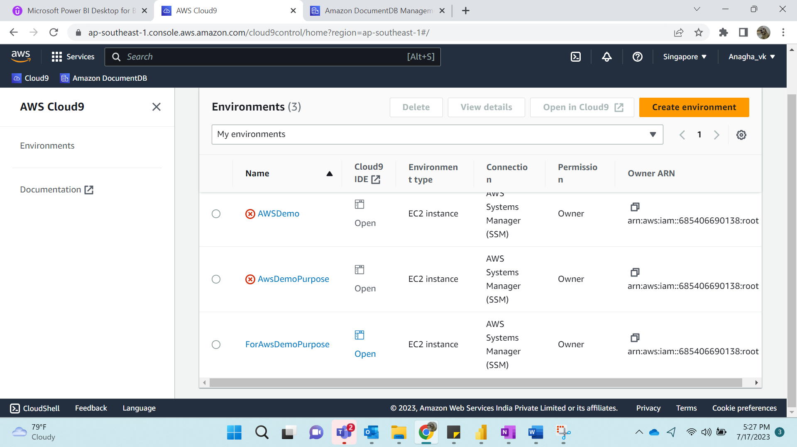

At the command prompt, create the repository file with the following command:

sudo su –

cd /etc/yum.repos.d

vi mongodborg-4.0.repo

[mongodb-org-4.0]  
name=MongoDB Repository  
baseurl=<https://repo.mongodb.org/yum/amazon/2013.03/mongodb-org/4.0/x86_64/>  
gpgcheck=1  
enabled=1  
gpgkey=<https://www.mongodb.org/static/pgp/server-4.0.asc>

save the file and install the mongo shell.

sudo yum install -y mongodb-org-shell

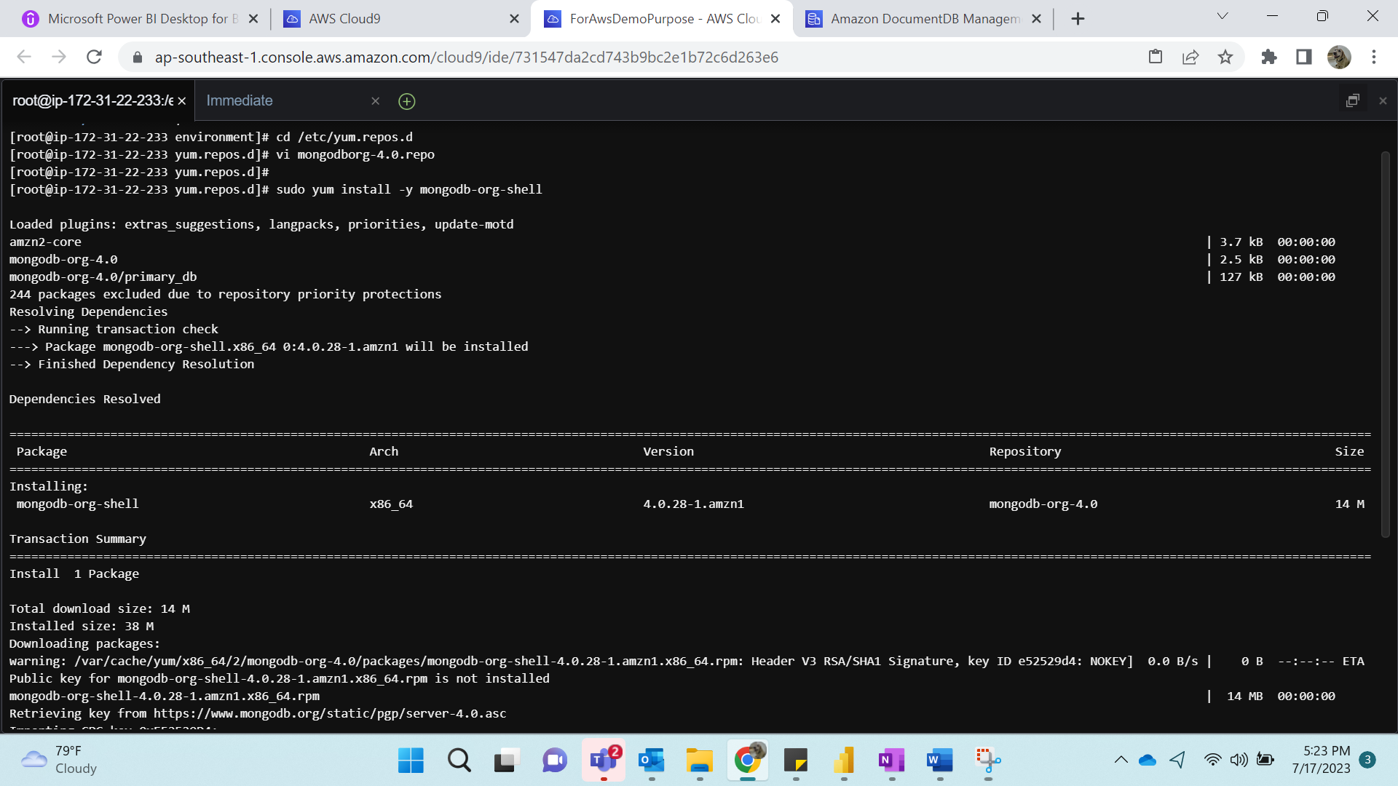

Edit the mongodborg-4.0.repo file

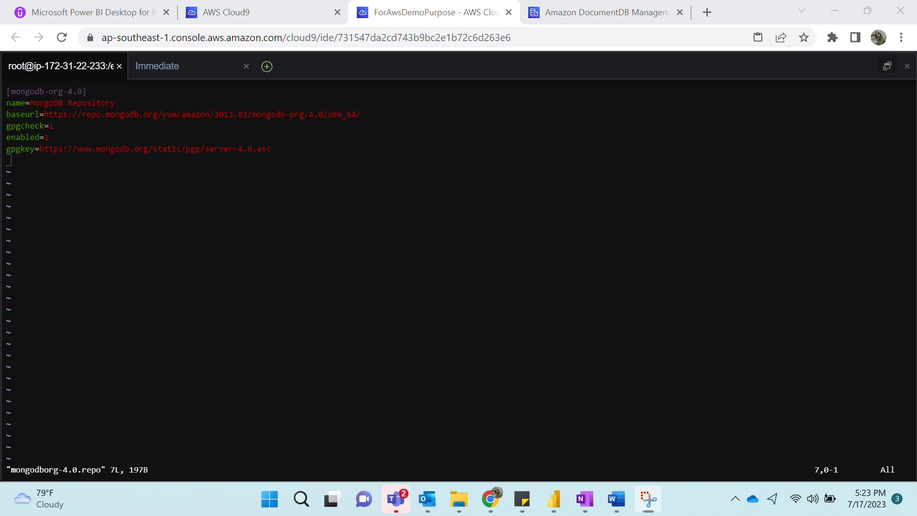

**Step 5:**

To encrypt data in transit, download the public key for Amazon DocumentDB

wget https://truststore.pki.rds.amazonaws.com/global/global-bundle.pem

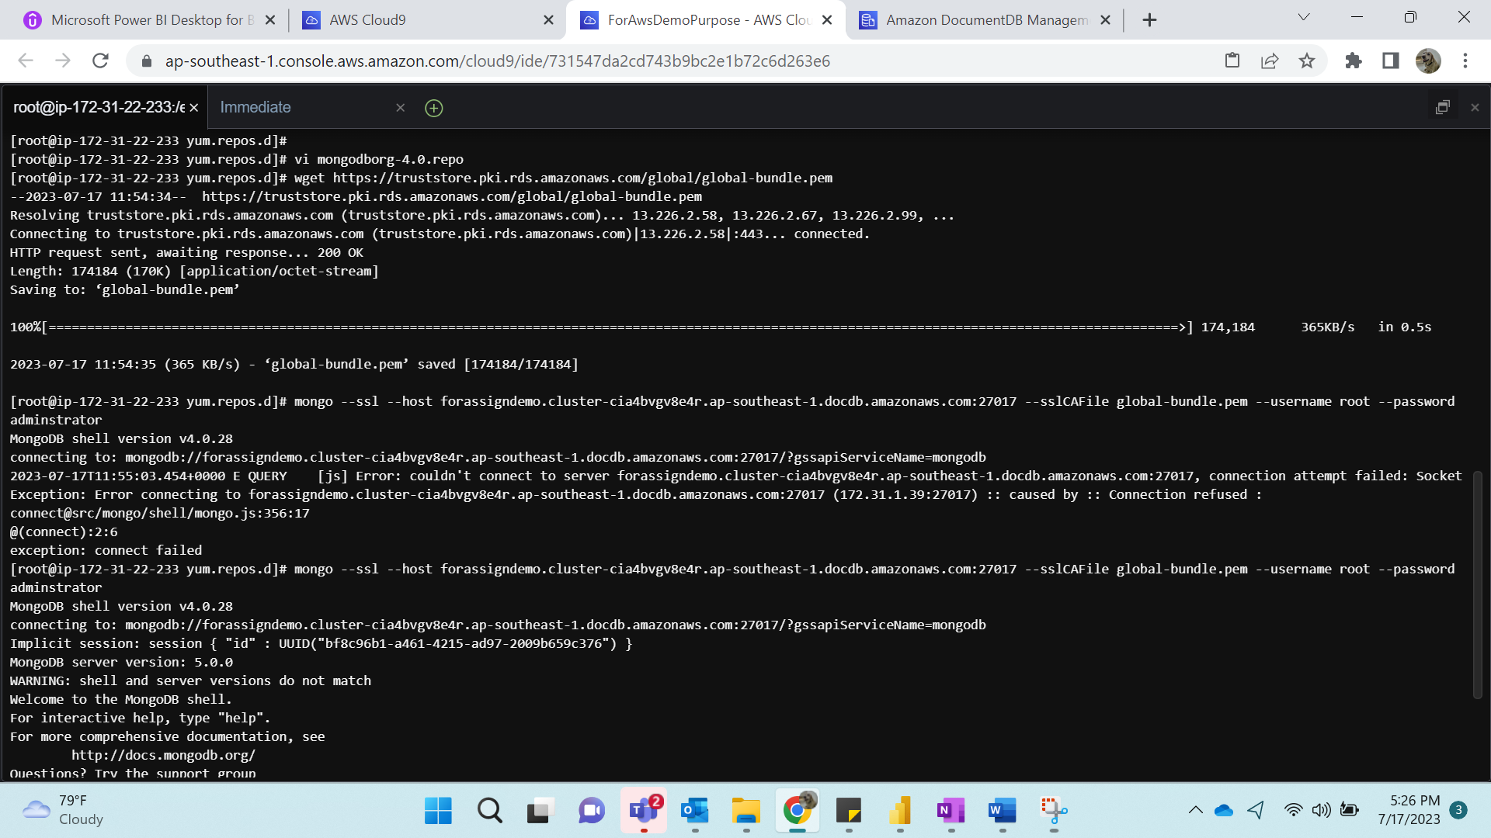

**Step 6:**

mongo --ssl --host forassign1demo.cluster-cia4bvgv8e4r.ap-southeast-1.docdb.amazonaws.com:27017 --sslCAFile global-bundle.pem --username root --password <insertYourPassword>

